DERIVATION OF VOLTAGE SOURCE MULTILEVEL CONVERTER TOPOLOGIES
ABSTRACT
Multilevel converters (MLCs) have emerged as standard power electronic converters in high power as well as quality demanding applications. They are classified into current-fed MLCs and voltage-fed MLCs. Voltage-fed MLCs have widely researched whereas the current-fed MLCs are the recent topic of research. Based on the principle of duality between voltage and current sources, several current-fed MLCs analogous to voltagefed MLCs have been identified. Current-fed MLCs offer several advantages in terms of high power capability, transformerless operation, short-circuit protection, and excellent quality of output current waveform. The goal of this paper is: 1) to present review of circuit topologies, modulation schemes, and applications of current-fed MLCs; and 2) to review an emerging lowdevice switching frequency modulation technique known as synchronous optimal pulsewidth modulation for current-fed MLCs. The circuit configuration and advantages of each topology along with various modulation techniques are discussed in detail. Compared to voltage-fed MLCs, the operation of current-fed MLCs need to satisfy additional switching constraints. A survey of classical methods for realization of these operational constraints has been done and a new generalized method has been proposed. Finally, future scope of research has been presented to encourage further development of topologies and modulation techniques for current-fed MLCs.

BLOCK DIAGRAM FOR PROPOSED SYSTEM
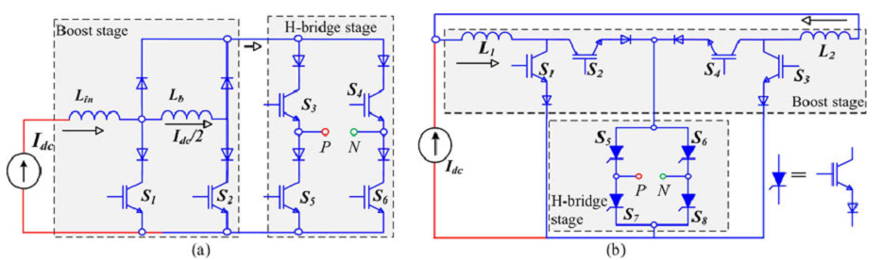
Fig. 1 Two-stage current-fed MLC. (a) Boost stage using multi-rated cell. (b) Boost stage using single rated cell.
DESIGNG SOFTWARE AND TOOLS:
MAT LAB /SIMULATION Software and simu power systems tools are used. Mainly control system tools, power electronics and electrical elements tools are used.

